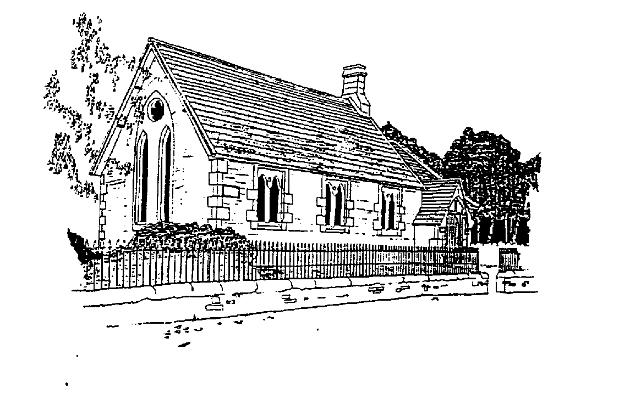

Westerkirk Parish Library
A Registered Scottish Charity. Number: SC020308

Newsletter: February 2023
It’s over six months since we put out a newsletter so given recent announcements of funding for the library it seemed timely.
In September we were open for Doors Open Days Dumfries and Galloway on the same day as the Benty Show and recorded a good number of visitors to the library.
At the start of October I took part in the Rotary Club of Langholm’s Umbrella walk and managed to raise £871 for the library. We are very grateful to the Rotary Club for helping to boost our funds at a time when energy costs have been rising rapidly. Running the dehumidifiers and heaters is costly and we don’t have much income.
We held our Annual General Meeting on 29th October and the same office bearers have been re-elected.
Crossdykes Community Benefit Fund opened for applications at the end of the year and I submitted an application to them for a grant for a number of things with the main aim being to increase membership and visitors to the library. We have secured just over £23,491 over a three year period and our plans are as follows:
- Employ someone for 7 hours a week to open up the library more often
- Hire a portaloo so that at least there are some facilities for visitors and researchers – it is very difficult to increase visitors without a loo!
- Purchase children’s books
- Hold events to encourage people to come to the library – these might be things such as book readings by authors
- Create a new printed guide to the library
- We also aim to install a phone line and broadband
We have also been awarded £3292 by the Arthur Bell Trust and are very grateful to the trustees for that award and this will also help us deliver on the actions outlined above
We hope to set up social media for the library to help to publicise it – if you’re on Facebook look out for it. This might also enable us to connect with other places across the UK connected to Thomas Telford such as the Caledonian Canal.
We had halted book purchases – Tom was the main book buyer – but as mentioned above hope to buy children’s books for the young people in the community soon – they are our future. We also acquired some books from Tom’s personal library.
We are grateful to all our supporters and hope that you will join in with our events and activities in 2023.

Mairi Telford Jammeh, Chair, Westerkirk Parish Library Trust

